SQL Practice PART 01

**Query 1**

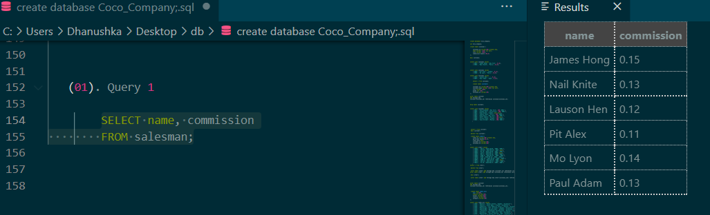 **• Display name and commission for all the salesmen.**

**Query 2**

**• Retrieve salesman id of all salesmen from orders table without any repeats.**

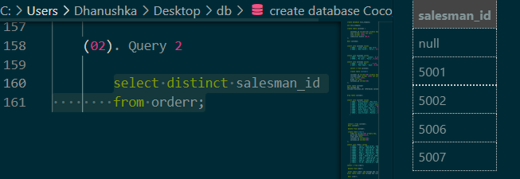

**Query 3**

**• Display names and city of salesman, who belongs to the city of Paris.**

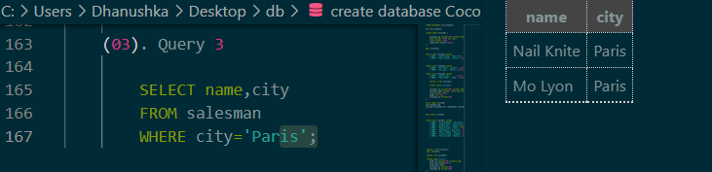

**Query 4**

**• Display all the information for those customers with a grade of 200**.

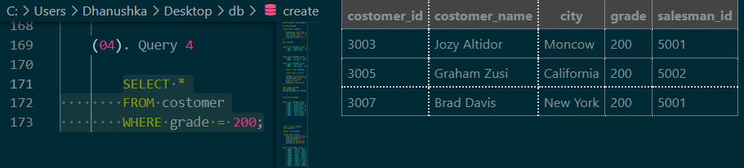

**Query 5**

**• Display the order number, order date and the purchase amount for order(s) which will be delivered by the salesman with ID 5001**

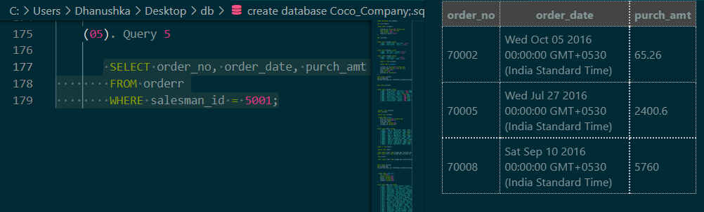

**Query 6 (table: nobel_win)**

**• Show the winner of the 1971 prize for Literature.**

SELECT winner FROM nobel_win WHERE year = 1971 AND subject = 'Literature';

**Query 7**

**• Show all the details of the winners with first name Louis.**

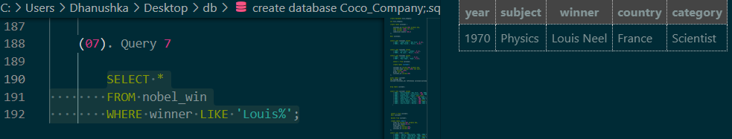

**Query 8**

**• Show all the winners in Physics for 1970 together with the winner of Economics for 1971.**

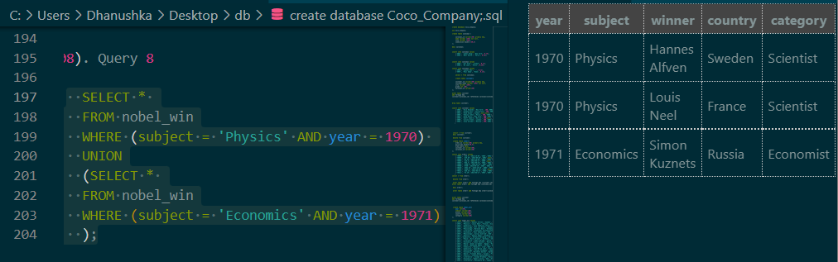

**Query 9**

**• Show all the winners of Nobel prize in the year 1970 except the subject Physiology and Economics.**

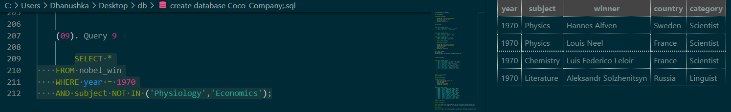

**Query 10**

**• Find all the details of the Nobel winners for the subject not started with the letter 'P' and arranged the list as the most recent comes first, then by name in order.**

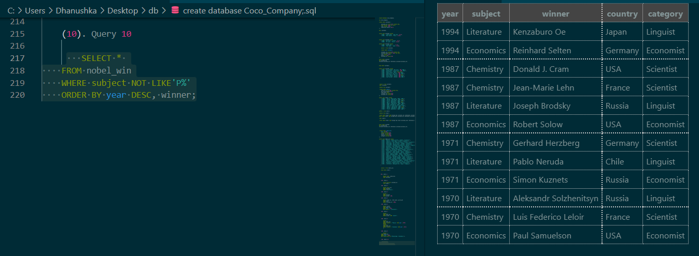

**Query 11 (table: item_mast)**

**• Find the name and price of the cheapest item(s).**

SELECT pro_name, pro_price FROM item_mast WHERE pro_price = (SELECT MIN(pro_price) FROM item_mast);

**Query 12 (table: customer)**

**• Display all the customers, who are either belongs to the city New York or not had a grade above 100.**

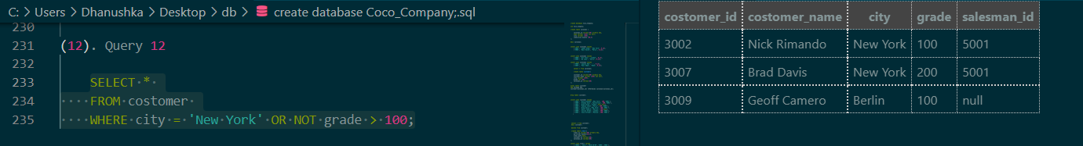

**Query 13 (table: salesman)**

**• Find those salesmen with all information who gets the commission within a range of 0.12 and 0.14.**

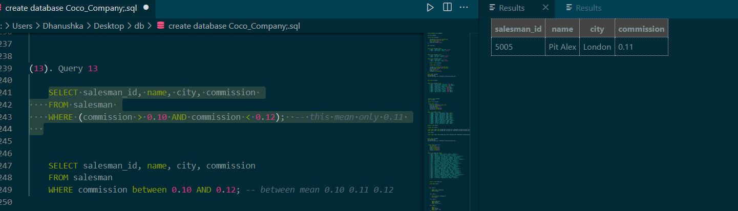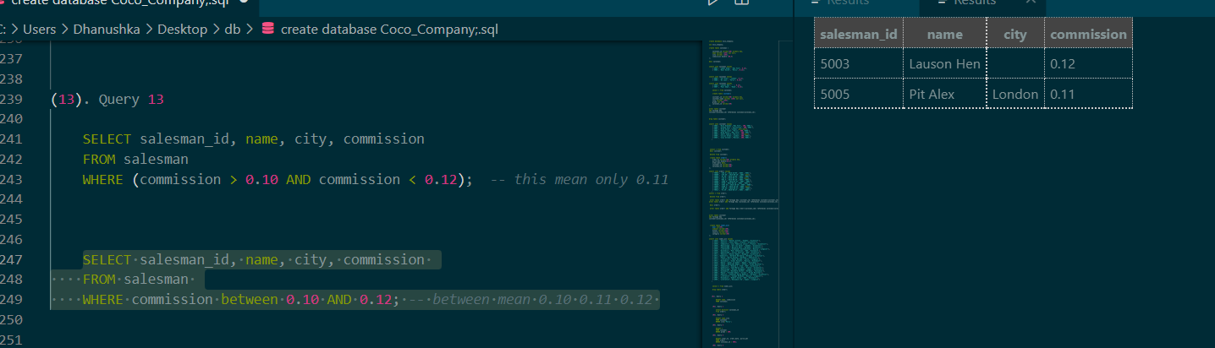

**Query 14 (table: customer)**

**• Find all those customers with all information whose names are ending with the letter 'n'.**

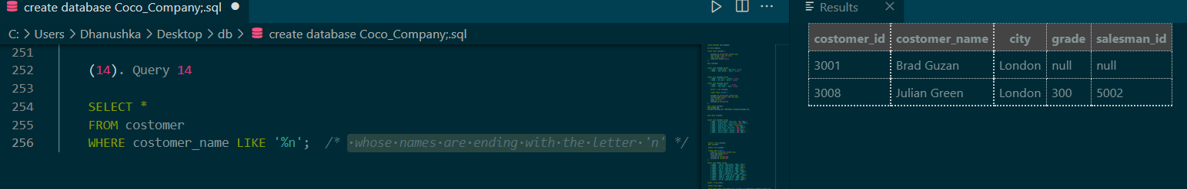

**Query 15 (table: salesmen)**

**• Find those salesmen with all information whose name containing the 1st character is 'N' and the 4th character is 'l' and rests may be any character.**

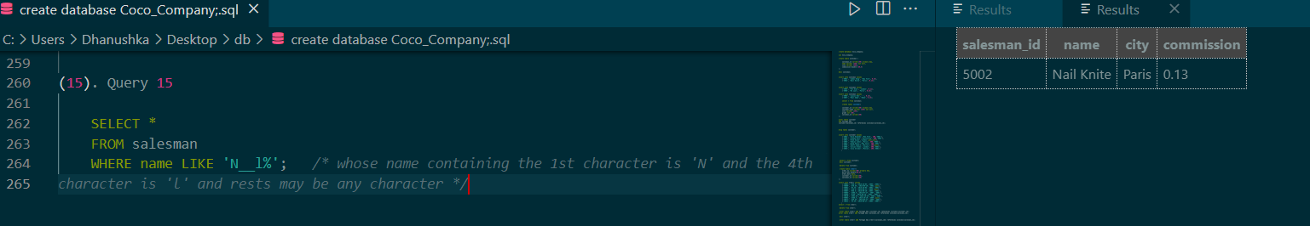

**Query 16 (table: customer)**

**• Find that customer with all information who does not get any grade except NULL.**

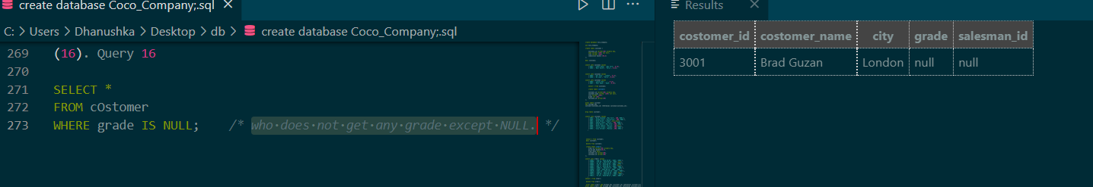

**Query 17 (table: orders)**

**• Find the total purchase amount of all orders.**

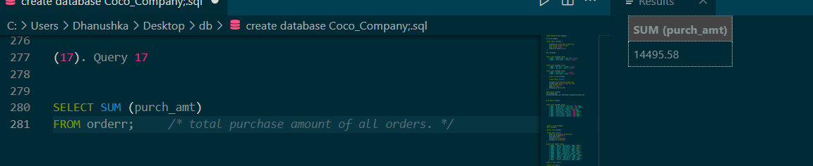

**Query 18 (table: orders)**

**• Find the number of salesman currently listing for all of their customers.**

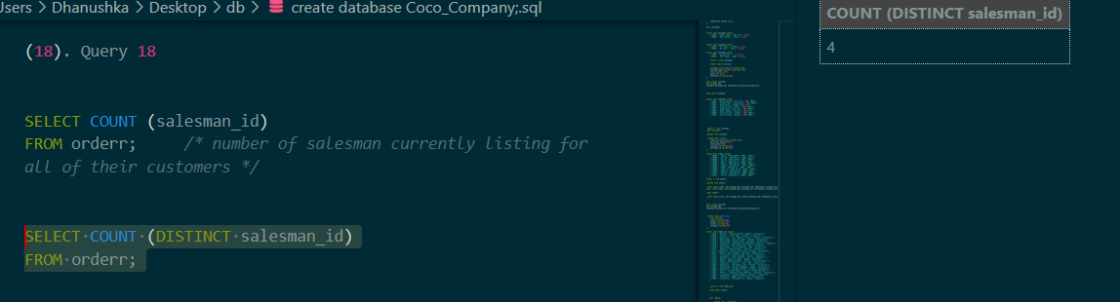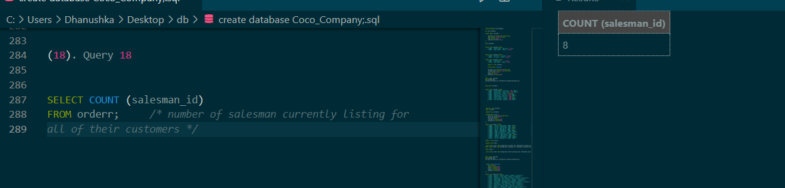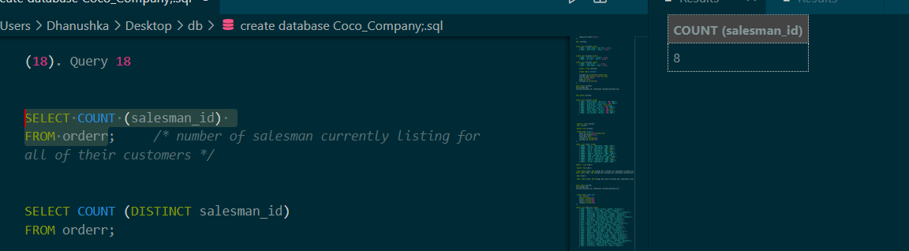

**Query 19 (table: customer)**

**• Find the highest grade for each of the cities of the customers.**

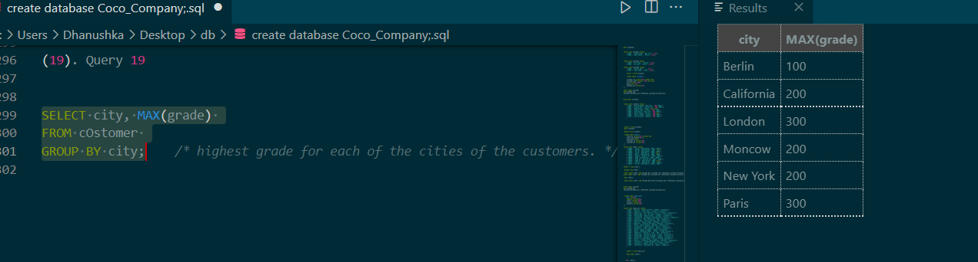

**Query 20 (table: orders)**

**• Find the highest purchase amount ordered by the each customer with their ID and highest purchase amount.**

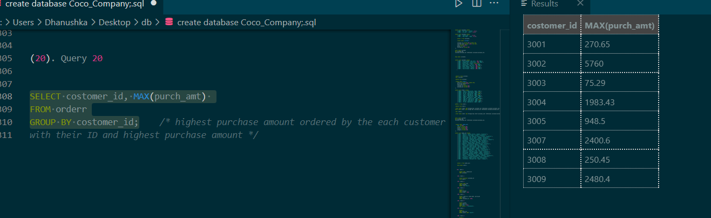

**Query 21 (table: orders)**

**• Find the highest purchase amount ordered by the each customer on a particular date with their ID, order date and highest purchase amount.**

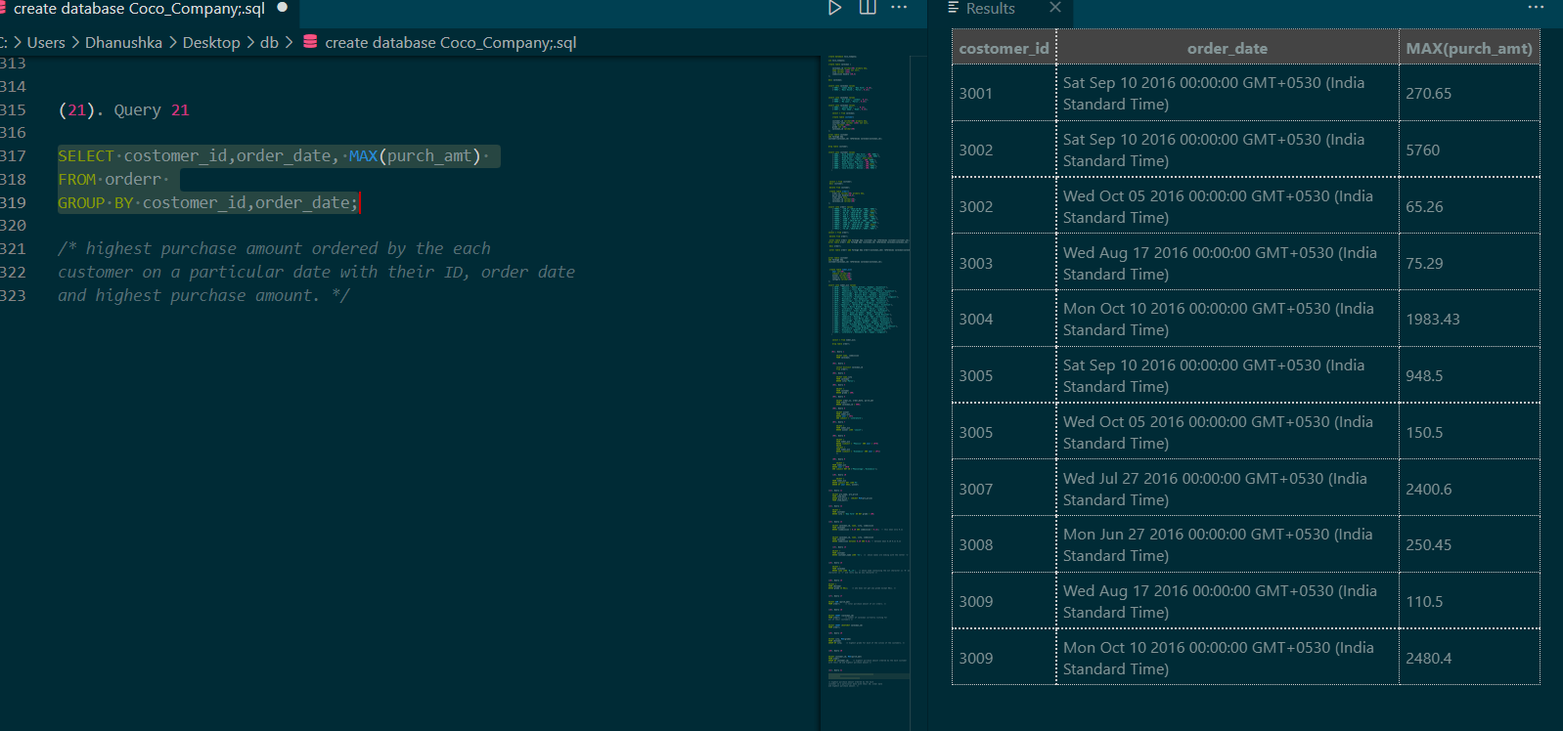

**Query 22 (table: orders)**

**• Find the highest purchase amount on a date '2012-08-17' for each salesman with their ID**.

SELECT salesman_id, MAX(purch_amt)

FROM orderr

WHERE order_date = '2012-08-17'

GROUP BY salesman_id;

**Query 23 (table: orders)**

**• Find the highest purchase amount with their customer ID and order date, for only those customers who have the highest purchase amount in a day is more than 2000.**

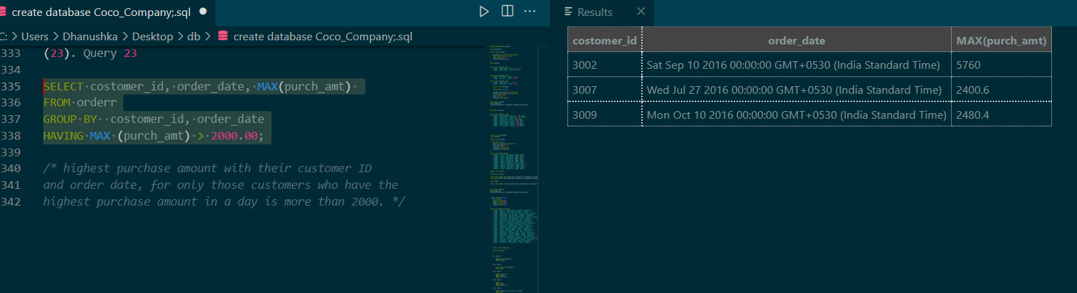

**Query 24 (table: orders)**

**• Write a SQL statement that counts all orders for a date August 17th, 2012.**

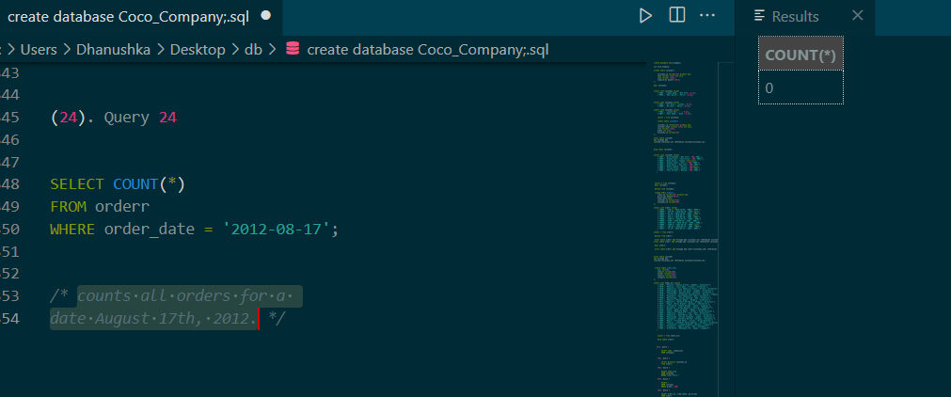

**Use this link to get codes:**

[**https://github.com/DHANUSHKAgitWICKRAMASINGHE/SQL_Practice.git**](https://github.com/DHANUSHKAgitWICKRAMASINGHE/SQL_Practice.git)